**DIGITAL SIGNAL PROCESSING LAB(BECE301P)**

Due Date: 20-1-25 Lab Slot:L35+L36

Name: ISHAAN KEDAR Reg.No:22BEC0153

**Objective:**

To use MATLAB to obtain the output of the LTI systems that are represented

using Linear Constant Coefficient Difference Equation (LCCDE).

**NOTES: Solution of an LCCDE Using MATLAB**

The MATLAB built-in function filter can be used to compute the response of LTI

systems that are represented using LCCDE. The filter function with the following

syntax.

y = filter(b, a, x)

Which filters the input data x using a rational transfer function defined by the numerator

and denominator coefficients b and a. It should be noted that the output signal generated

from filter function has same length as the input signal.

The MATLAB built-in function conv can also be used to compute the response of LTI

systems with impulse response h as follow,

y = conv(x, h)

The length of the output signal using the above regular convolution will be as follow

length(x) + length(h) - 1

**TASK PROBLEMS:**

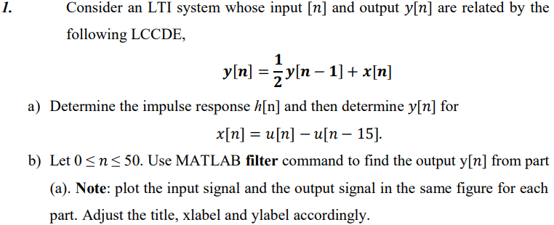

**Code:**

**a)**

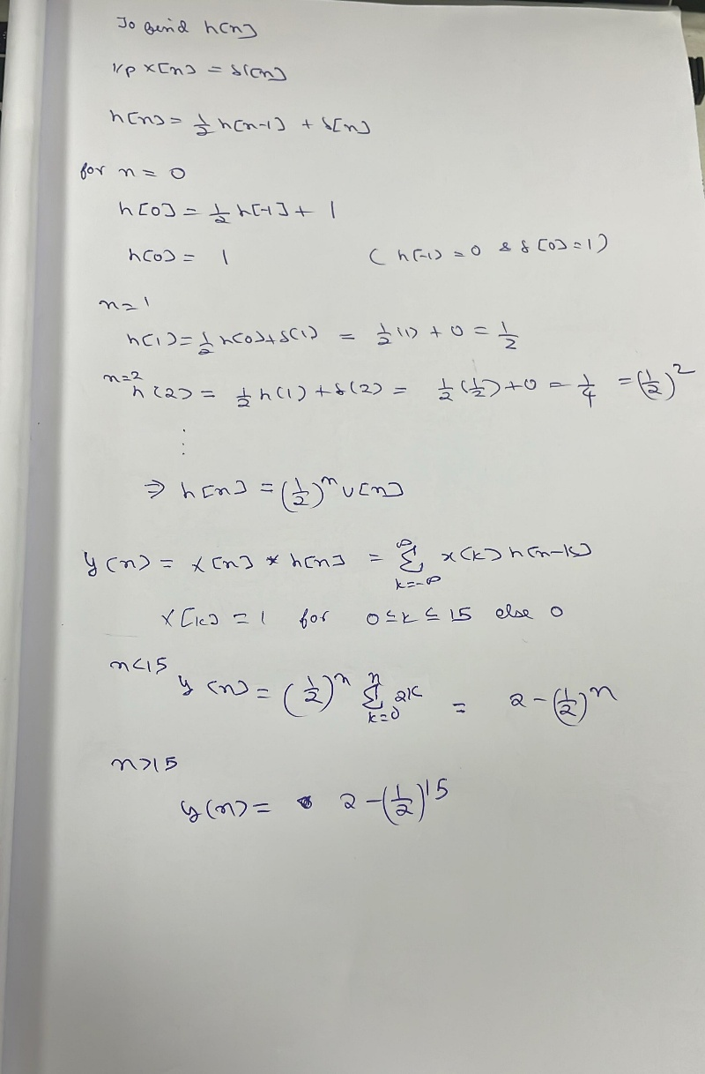

**b)**

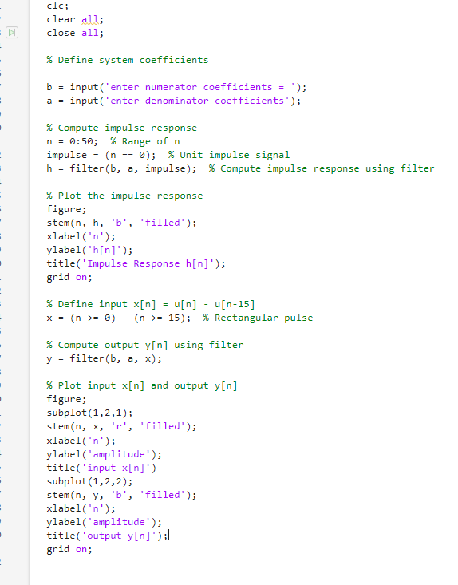

**Output:**

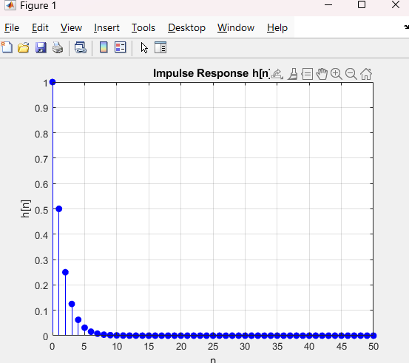

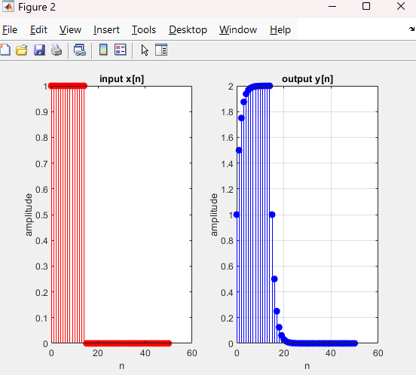

**Inference:** The impulse response in figure 1 shows an exponential decay indicating a stable system.

The input and output graphs indicate that the system applies h[n] to x[n] so we get a similar response as the input but the signal attenuates over time.

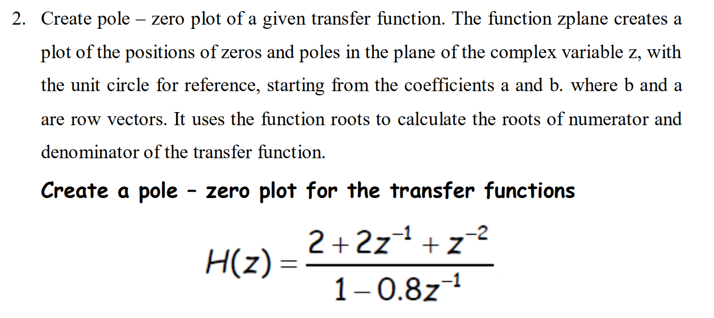

**Code:**

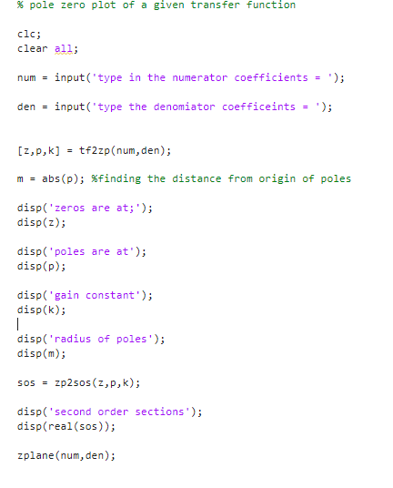

**OUTPUT:**

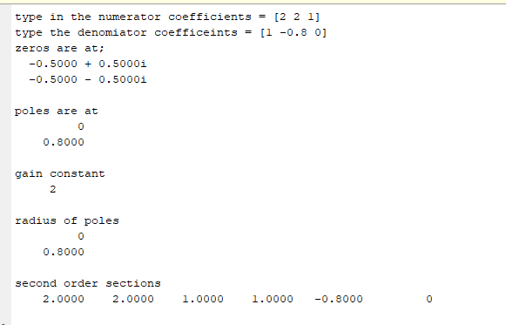

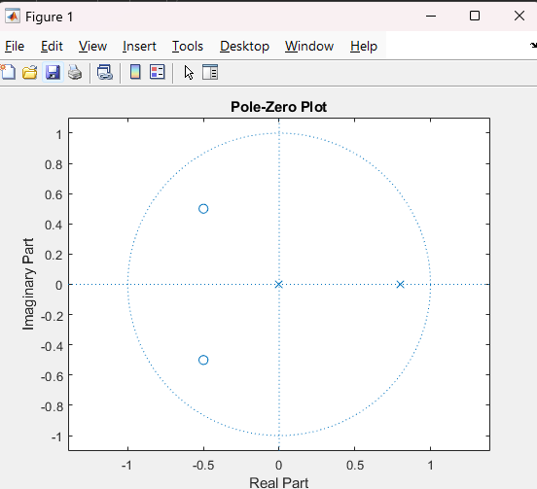

**Inference:** the poles occur at 0 and 0.8 indicated by the x while the zeros occur at -0.5 + 0.5i and 0.5 – 0.5i indicated by o.

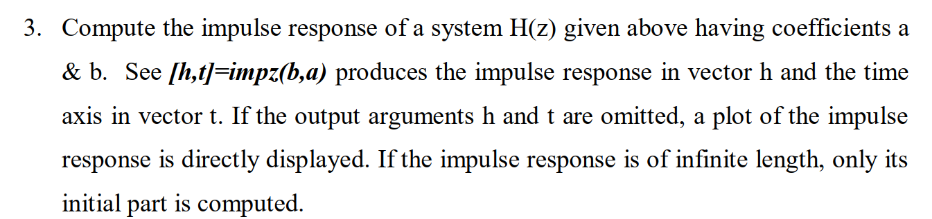



**Code:**

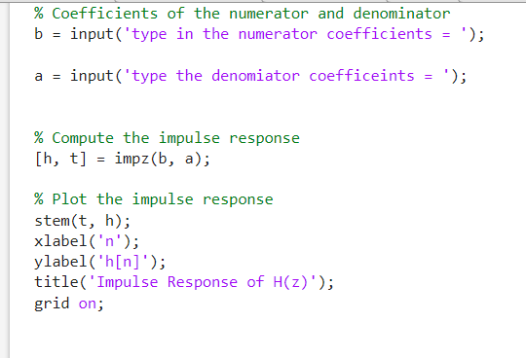

**Output:**

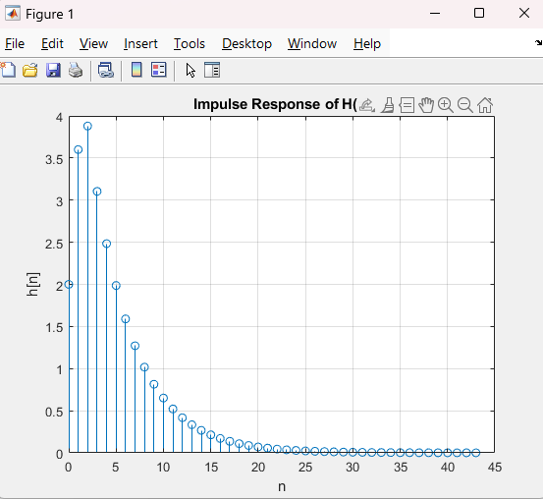

**Inference:** The impulse response shows an exponential decay indicating that the system is stable. Also the system response is non zero indicating that the system is causal.

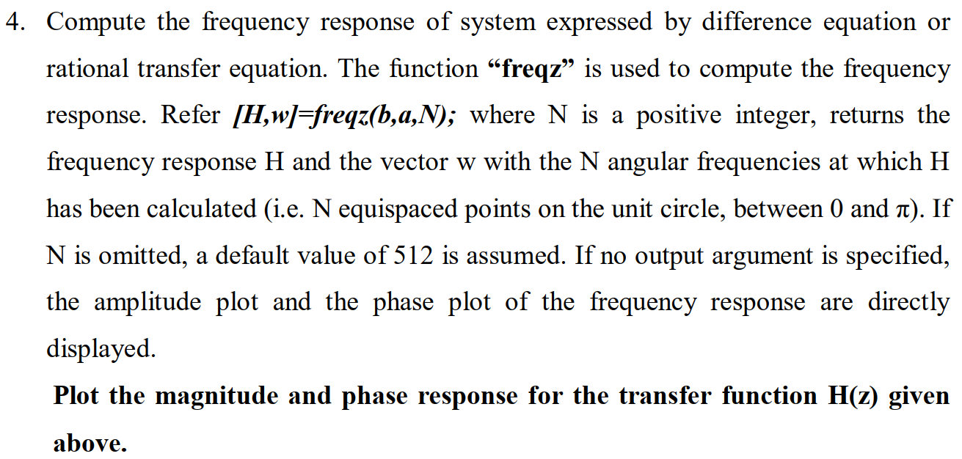



**Code:**

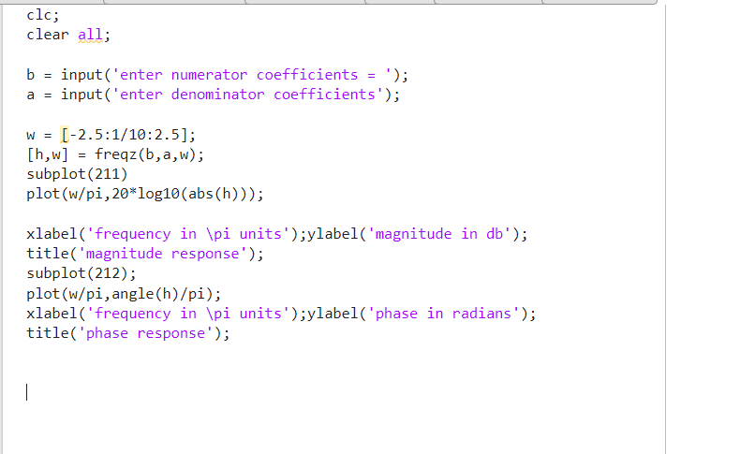

**Output:**

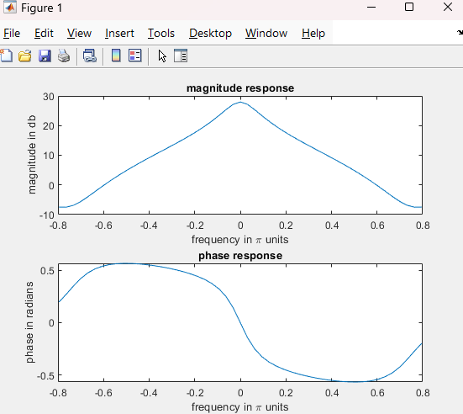

**Inference:** The magnitude response indicates how the magnitude of the function varies with frequency. Shows attenuation for higher and lower frequencies relative to the peak.

Phase response indicates the variation of phase of the function with frequency. The phase shift occurs continuously with frequency smoothy transitioning through zero indicating a stable system.